Quaid-e-Azam College of Commerce, University of Peshawar
Final-Term Examination
M.Com Two-Year (2019-21) 1st Semester
Program | Exam Hall | Time | Friday | Monday | Tuesday | Wednesday | Thursday | Friday2
 |  |  | 13-03-20 | 16-03-20 | 17-03-20 | 18-03-20 | 19-03-20 | 20-03-20
M.Com  2 Years  Final-Term | R.1 | 9:00 | (Faheem)  Principles of Mangement | (Farrukh)  Business Mathematics | (Dr. Faisal)  Financial Management | (Jamal)  Principles of Marketing | (Dr. Hamid)  Logic and Critical Thinking | (Ilyas)  Corporate Accounting
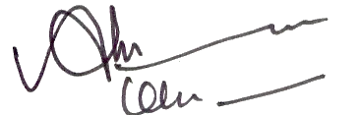

Coordinator Examinations |  |  |  |  |  |  |  | 02-03-20

